HOW TO CREATE RULES IN PFSENSE

Step 1: Create Aliases

1. Browse the firewall → Aliases.
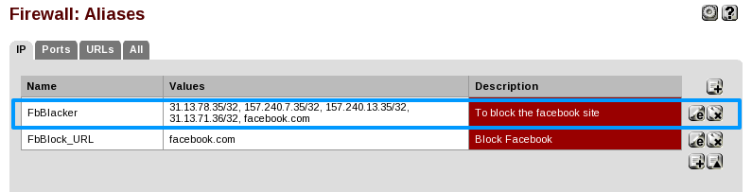
2. Click on the plus button to add a new alias.
3. Add a name of the alias.
4. Select an alias type and configure the that type related configuration.
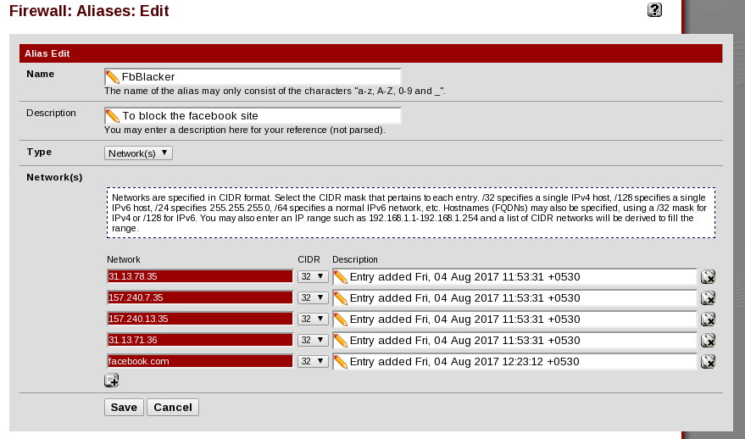
5. Save changes and apply the changes.

Step 2: Create Firewall Rules
1. Browse to firewall / rules
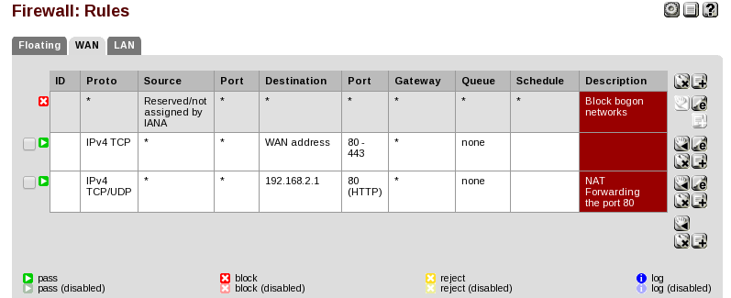
2. Select the lan interface to careate a firewall rules.
3. Click on the plus button to create a new lan rule.
4. Seclect the interface as lan and select the internet protocol has tcp/udp.
5. for destination type is single host, and select the particular rules of alias.
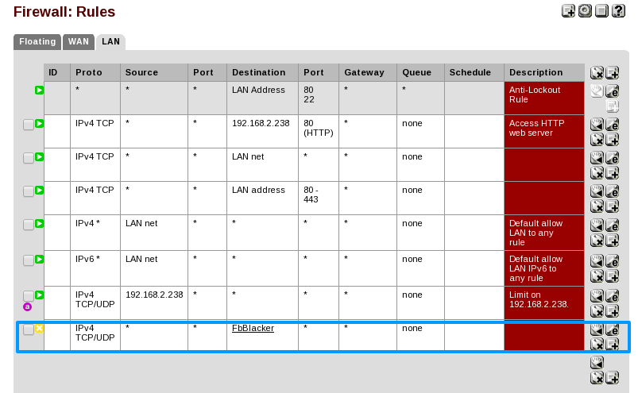
6. Save the changes and apply the changes.
7. finally we have successfully completed and blacked the facebook related web pages.

